**Project Name:**

**inventory management system**

**technology Stack:**

**Backend: Java**

**Frontend: java swing**

**Database: Sqlite**

**Intro about project:**

**This project is Multiuser Inventory management system**

**That allow admin to edit and manage user password and**

**Username, add and manage Products, Add new category**

**To the system, add all our customer in one place so that we can keep track of all our customer and its purchases, and the**

**Most important function of this project is to add order and keep track of customer-products list so that we can edit it and**

**We can print it.**

**Link to GitHub:**

**\*Private repo ask for permission to get access**

[**https://bit.ly/3vIdTYE**](https://bit.ly/3vIdTYE)

**Business Process & Business rules**

**Business process:**

**Add new product to inventory.**

**receive orders and keep track of it’s status.**

**Manage customer order.**

**Business rules:**

**To add new product, it must be unique and difference from The rest in the product section.**

**Only admin has access to edit and delete employee name and password.**

**We only receive order if and only if we have all the items required in our inventory.**

**We can print any order in any time and see what it’s status.**

**The employee can receive and add order and print order status.**

**Class Diagram of our system:**

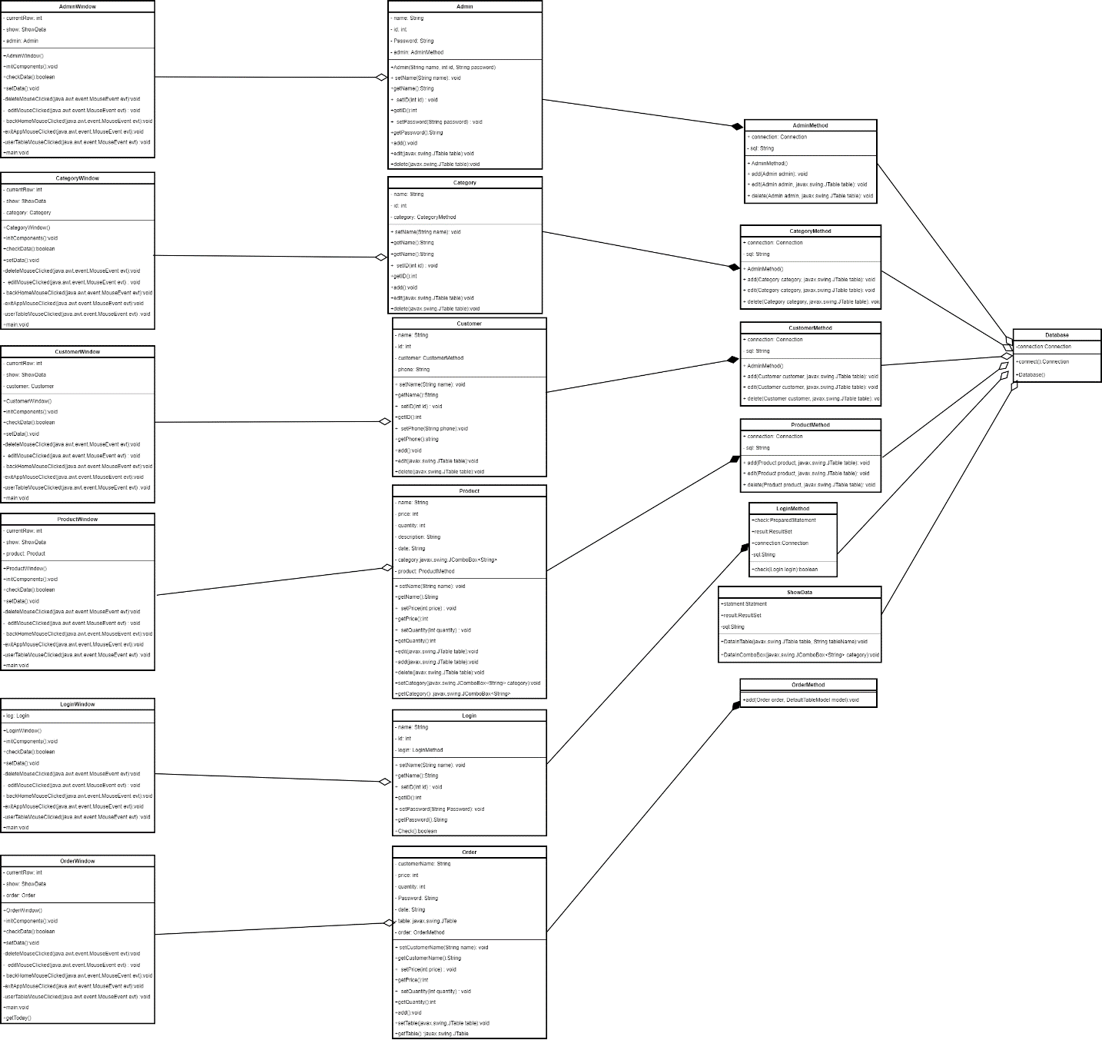

**Activity Diagram of our system:**

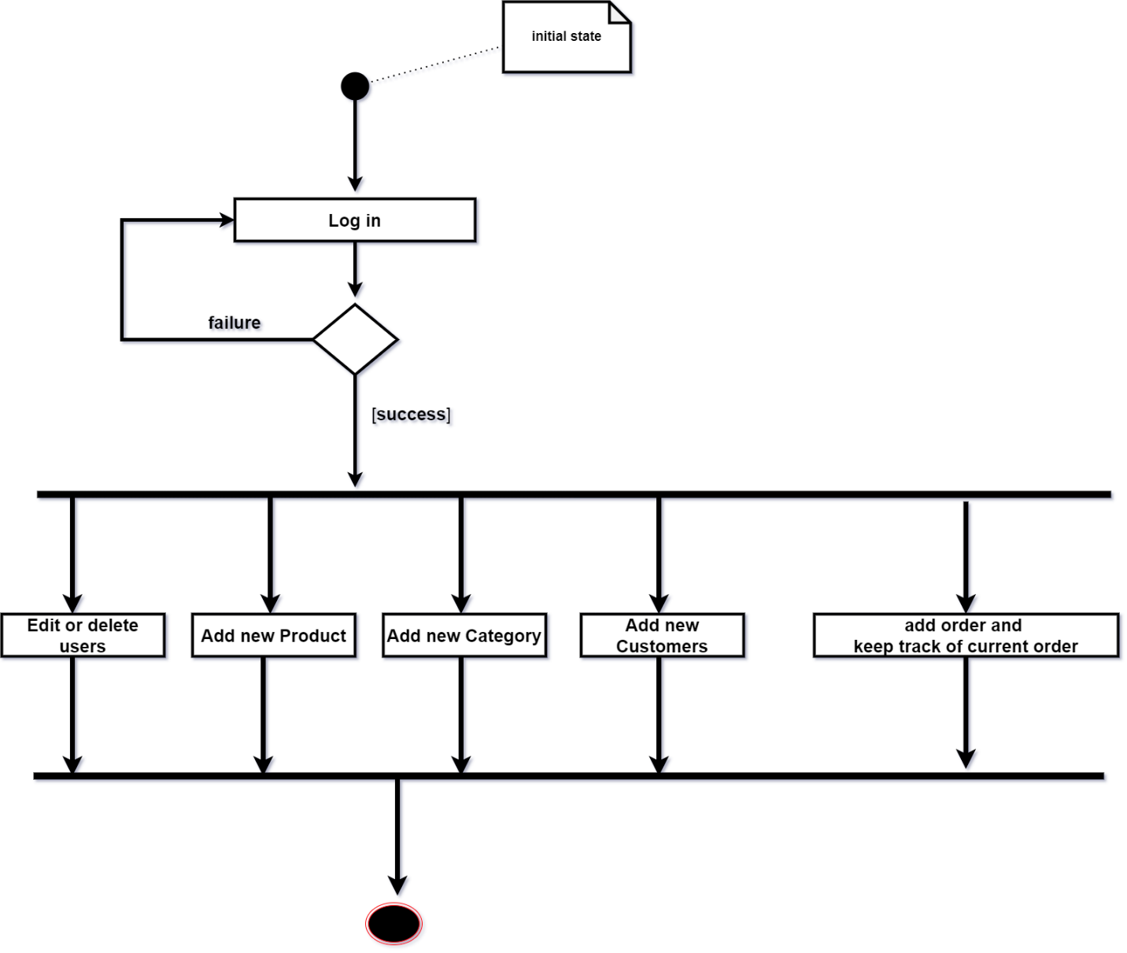

**Use-case Diagram of our system:**

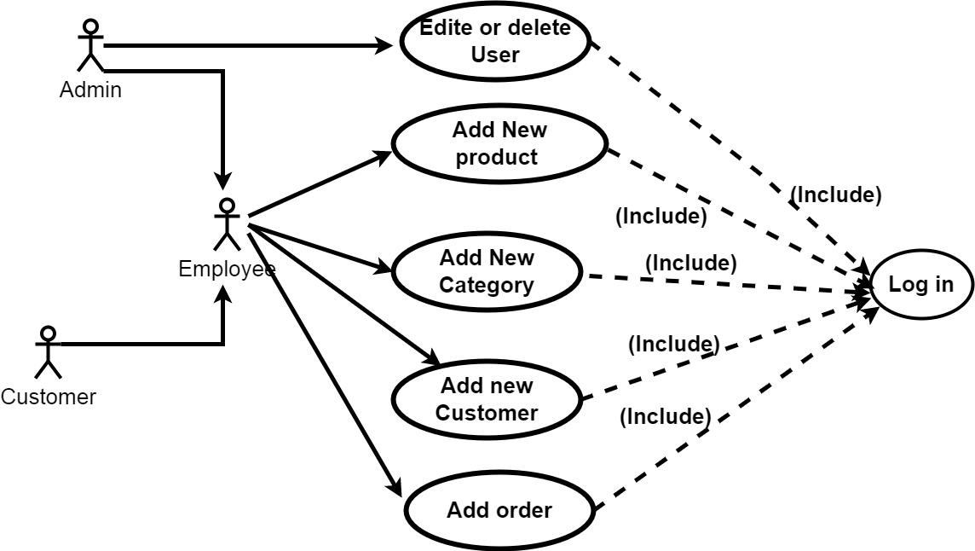

**Database Diagram of our system:**

